Name: Muhammad Owais Bawany

Student no: 7993647

Course: CSI 4142 Intro to Data Science

Professor: Herna L Viktor, PhD

Assignment 1 2018

1. Grain of this dimensional model would be an individual UFO reported by duration.  
   Location Dimension, Reported Date, Shape Dimension  
   An individual UFO sighting report that gives information about a sighting that occurred at a specific date, was reported at a specific date, at a location, with a certain reported shape.
2. Event date (observation date) is the missing dimension from this model, by looking at the dimensional model there is only one date, which is the posted date. If it was event date, there would be a missing piece of information (date). We need a dimension that records the date and time of the sighting.   
   The Event-Date dimension should have a Event-Date-key, Time, Date, Week, Month, Year, Weekend (Y/N), Season (Winter, Spring, Summer, Fall), Special-Event
3. A fact is a concept relevant to decision-making processes. It typically models a set of events taking place within a company. In our given example, UFO Fact would be considered a fact.  
   A measure is a quantitative indicative of the fact table. Which are numeric and additive rules. Other measures that could’ve been added to the design would be the size, speed, height-of-flight, color of the UFO. Although measures like size, speed and height-of-flight could be practically hard to judge. Even color is subjective and difficult to describe often.
4. Concept Hierarchy reduce the data by collecting and replacing low level concepts with higher level abstractions. It’s a partially disordered set. They are sometimes used to generalize data while sometimes used to specialize data by replacing higher level abstractions with lower level concepts.In our example we could replace the Year format from (day-month-year) to (year) or the area format from (region-country-state-city) to country.
5. A year-shape aggregate could be implemented to speed up OLAP queries. E.g: All circular shaped UFO’s spotted in 1980, all square shaped in 1800…   
   Or a Monthly UFO reported by location could be another aggregate.
6. Shape and Duration in has some missing values. Aggregation could be done for missing fields.
7. There’s no correlation in my opinion.

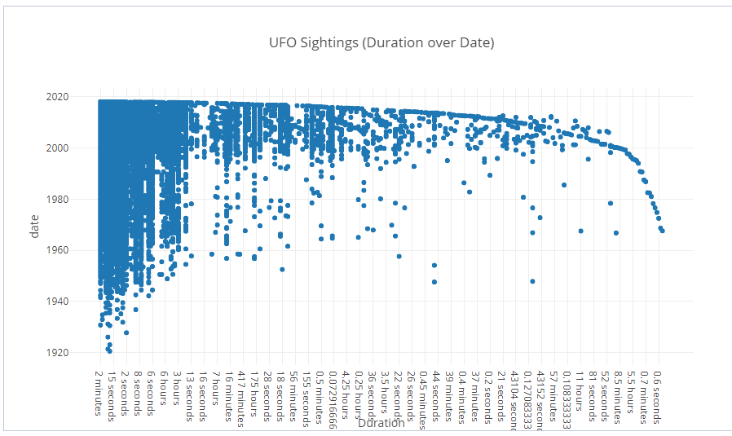

1. Each entry (or bit) in the bitmap corresponds to a single row of the customers table. The value of each bit depends upon the values of the corresponding row in the table. For our example, the bitmap is_delta = ‘Delta’ contains a one as its first bit because the region is east in the first row of the customers table. The bitmap not_delta = NOT ‘Delta’ has a zero for its third bit because the value of the third row is not ‘Delta’. Note, you cannot have both values at 0, this would imply the value is both delta and not delta.  
   Have one bitmap for each state, whenever a record has the shape DELTA insert a 1 to the corresponding state otherwise insert 0. The answer to the query will be all states that contains a 1 in its respective bitmap.

1. A semi-join returns rows from the first input if there is as least one matching row in the second input. So in our example you would first pull all sightings from 2017 (first input), and then check all that were diamond shaped (second input). Your bitmap would then have its two collumns, BUT would only be comparing sightings in 2017, and not the entire database. Your first column would be id, second column is_diamond is 1 when shape = ‘diamond’, and not_diamond is 1 when shape = NOT ‘diamond’. Note, again you cannot have a row in which both values are zero.   
     
   In order to optimize the query, SEMI-JOIN would return ROW-IDs that match the query in the dimensions and use a bitmap index to “AND” results.  
     
   SELECT COUNT(*)  
   FROM SEMI_JOIN DIMENSIONS  
   WHERE CONDITION1,   
    CONDITION2……..
2. Data mart was created using PGAdmin III on my localhost server. Our data had no possible combination of columns to make a UNIQUE Primary Key. So I used a column called id, in which its properties was simply of type ‘integer’, and it is serial.

DELETE FROM "RawTable";

COPY "RawTable"("eventDateTime","city","state","shape", "timeDuration","summary","datePosted")

FROM '/Users/obawany/Desktop/Winter 2018/CSI 4142 - Data Science /FIN.csv' DELIMITER ',' CSV HEADER;

DELETE FROM "UFO-Fact";

Delete FROM "Reported-Date";

Delete FROM "Location";

Delete FROM "Event-Date";

Delete FROM "Shape";

--From RAW to Location TABLE

INSERT INTO "Location" ("City","State","Location-Key")

SELECT "city", "state", "id"

FROM "RawTable";

/*

select *

from "Location";

*/

/*

Insert into "Location Dimension"("City","State","Location-key")

Select "Location", "State", "id"

FROM "UFO";

Insert into "Shape Dimension"("Shape-name","Summary", "Shape-key")

Select "Shape", "Description", "id"

FROM "UFO";

Insert into "Event-Date Dimension"("Date","Week","Month","Year","Weekend", "Event-Date key")

Select "Event_Date", EXTRACT(week FROM "Event_Date"), EXTRACT(MONTH FROM "Event_Date"), EXTRACT(YEAR FROM "Event_Date"),

CASE

WHEN to_char("Event_Date", 'D') = '7' THEN 'y'

WHEN to_char("Event_Date", 'D') = '1' then 'y'

ELSE 'n'

END, "id"

FROM "UFO";

Insert into "Reported-Date Dimension"("Date","Week","Month","Year","Weekend", "Reported-Date key")

Select "Posted_Date", EXTRACT(week FROM "Posted_Date"), EXTRACT(MONTH FROM "Posted_Date"), EXTRACT(YEAR FROM "Posted_Date"),

CASE

WHEN to_char("Posted_Date", 'D') = '7' THEN 'y'

WHEN to_char("Posted_Date", 'D') = '1' then 'y'

ELSE 'n'

END, "id"

FROM "UFO";

Insert into "UFO FACT"("Event Date key","Location key","Shape key","Reported Date key","Duration")

Select e."Event-Date key" , l."Location-key", s."Shape-key", r."Reported-Date key", u."Duration"

FROM "Location Dimension" l, "Shape Dimension" s, "Reported-Date Dimension" r, "Event-Date Dimension" e, "UFO" u

WHERE e."Event-Date key" = u."id" and u."id" = l."Location-key" and u."id" = r."Reported-Date key" and u."id" = s."Shape-key";

*/

--FROM RAW to Reported-Date TABLE

INSERT INTO "Reported-Date"("Date","Week","Month","Year","Weekend (Y/N)", "Reported-Date-Key")

SELECT "datePosted", EXTRACT(week from "datePosted"), EXTRACT(month from "datePosted"), EXTRACT(year from "datePosted"), CASE WHEN to_char("datePosted", 'D') = '7'THEN 'Y'

WHEN to_char("datePosted", 'D') = '1'THEN 'Y'

ELSE 'N'

END, "id"

FROM "RawTable";

/*

select *

from "Reported-Date";

*/

--FROM RAW to Event-Date TABLE

INSERT INTO "Event-Date"("Date","Week","Month","Year","Weekend (Y/N)", "Event-Date-key")

SELECT "eventDateTime", EXTRACT(week from "eventDateTime"), EXTRACT(month from "eventDateTime"), EXTRACT(year from "eventDateTime"), CASE WHEN to_char("eventDateTime", 'D') = '7'THEN 'Y'

WHEN to_char("eventDateTime", 'D') = '1'THEN 'Y'

ELSE 'N'

END, "id"

FROM "RawTable";

/*

select *

from "Event-Date";

*/

--FROM RAW to Shape TABLE

INSERT INTO "Shape" ("Shape-name", "summary", "Shape-Key")

SELECT "shape", "summary", "id"

FROM "RawTable";

/*

select *

from "Shape";

*/

Insert into "UFO-Fact"("Event-Date-key","Location-Key","Shape-Key","Reported-Date-Key","timeDuration")

Select e."Event-Date-key" , l."Location-Key", s."Shape-Key", r."Reported-Date-Key", u."timeDuration"

FROM "Location" l, "Shape" s, "Reported-Date" r, "Event-Date" e, "RawTable" u

WHERE e."Event-Date-key" = u."id" and u."id" = l."Location-Key" and u."id" = r."Reported-Date-Key" and u."id" = s."Shape-Key";

**--Q11**

SELECT "Month", COUNT ("Month")

FROM "Event-Date"

GROUP BY "Month"

ORDER BY "Month";

**--Q12**

SELECT count(*), "Location"."State", "Reported-Date"."Month" FROM ("UFO-Fact" INNER JOIN "Location" ON "Location"."Location-Key" = "UFO-Fact"."Location-Key")

INNER JOIN "Reported-Date" ON "Reported-Date"."Reported-Date-Key" = "UFO-Fact"."Reported-Date-Key" GROUP BY "Location"."State", "Reported-Date"."Month";

**--Q13**

SELECT COUNT("Shape-name"), "Shape-name", AVG("UFO-Fact"."timeDuration")

FROM (public."UFO-Fact"

INNER JOIN public."Shape"

ON "UFO-Fact"."Shape-Key" = "Shape"."Shape-Key") GROUP BY "Shape-name" ORDER BY 1 DESC LIMIT 5;

**--Q14**

SELECT s."Shape-name", AVG(u."timeDuration") as avg_duration, l."State", MAX(u."timeDuration") as max_duration

FROM "Shape" s, "UFO-Fact" u, "Location" l

WHERE s."Shape-Key" = u."Shape-Key" AND l."Location-Key" = u."Location-Key"

GROUP BY l."State", s."Shape-name" ORDER BY max_duration desc;

**--Q15**

SELECT count(*), "Shape", "State" FROM ("UFO-Fact" INNER JOIN "Location" ON "Location"."Location-Key" = "UFO-Fact"."Location-Key")

INNER JOIN "Event-Date" ON "Event-Date"."Event-Date-key" = "UFO-Fact"."Event-Date-key" INNER JOIN "Shape"

ON "UFO-Fact"."Shape-Key" = "Shape"."Shape-Key"

WHERE ("Location"."State" = 'CA' OR "Location"."State"= 'FL') AND "Event-Date"."Weekend (Y/N)" = 'Y' GROUP BY "State", "Shape";

